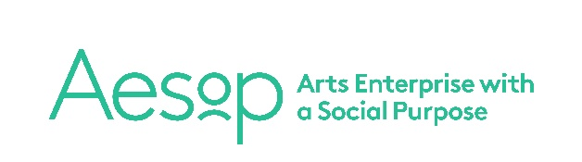
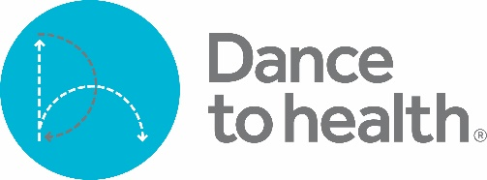

Information for Applicants

Dance to Health is the nationwide, pioneering, falls-prevention dance programme for older people. We combine evidence-based falls-prevention principles with the creativity, expression and energy of dance. Our sessions are led by professional dance artists who have been fully trained in falls-prevention exercise methods. Dance to Health is created and managed by Aesop Arts and Society Ltd. Find more on our website www.dancetohealth.org.

We have achieved great success with Phase One of Dance to Health, which ran from 2017 to 2019:
- Falls reduced by 58%
- 96% of participants say that their mental health and wellbeing has improved.
- 98% of participants would recommend Dance to Health to friends and family.
- Dance Artists report that there is great opportunity for creativity and practice development while incorporating the falls prevention principles.

Aesop is now delivering Phase Two of Dance to Health, creating more programmes across England and Wales in a variety of community and healthcare settings, both online and face-to-face.

How Dance to Health Operates

Our weekly classes are 90 minutes dance activity + 30 minutes social time at the end. This combination of dance activity and social time addresses the core problems older people experience when they are at risk of a fall; physical deconditioning, loss of confidence in one’s body and social isolation. We build up their strength, balance and physical confidence and provide a friendly and welcoming space for social interaction.

We run programmes which are commissioned by health boards, local councils or other community partners. Initial programmes of 26 weeks ensure participants experience a full 50 hours of activity from a combination of our session time and regular homework suggestions. We then follow on with programmes designed to maintain people’s physical improvements which run for a further 16 weeks, before supporting participants to set up independent, community interest groups, funding their Dance to Health group for the future.

Freelance Contracts

Each of our Dance Artists are self-employed professionals who work in a variety of community and arts projects alongside Dance to Health. Our contracts protect your freelance status and guarantee cancellation fees, help with substitution, flexible working around school holidays and a fair rate which is the same for all artists across the country.

At present we pay £2,080 for a 26 week programme, working out as £80 for a two hour session. We financially support, paying for candidates to gain the Later Life Training certification in falls prevention and require that at least one 26 week programme is delivered in return. We offer work by region or online to our dance artists as it comes in to us. Several artists have worked with us continually since 2017 and we are growing all the time!

Training Details

We are looking for dance artists and practitioners already working with older people or in arts and health, who want to develop their practice and strengthen their teaching. You will undertake training to gain a physiotherapy-based certification, Postural Stability Instructor, recognised by physiotherapy and healthcare providers.

Successful candidates will achieve the PSI (Postural Stability Instructor) certification through Later Life Training. This will be followed by Dance to Health’s Translation Training and you will become a fully trained dance artist and part of our team delivering the Dance to Health national programmes.

Aesop pays the course fees of £804. We also have a financial aid scheme to cover expenses or loss of income for anyone who would experience financial hardship as a result of attending the four day course.

PSI Course structure

The PSI certification involves online study and four face-to-face days including written and practical examination (PC access essential). Later Life Training provide an online learning portal for trainees which will open approx. four weeks before the course start date and they estimate 25 hours of home study may be required prior to the first face-to-face learning days. Home study and online learning is done in trainees’ own time.

- Online learning begins, then a gap of up to one month
- Day 1 + 2 – face-to-face learning with tutor, then a gap of one month
- Day 3 – written assessment and support from tutor, then a gap of one month
- Day 4 – practical assessment
- Case Study submission

Support is provided throughout by Later Life Training tutors. Previous candidates thoroughly enjoyed the face-to-face days, some candidates found aspects of the home study challenging. This course is equivalent level to a first year undergraduate module. All gained from the experience and found the process of embedding PSI principles within their dance practice valuable, enhancing their work with older people and beyond.

Please look at the Later Life Training website for full details of the PSI course requirements before making an application: https://www.laterlifetraining.co.uk/courses/postural-stability-instructor/

Note the course includes an adapted Tai Chi element, which can be worked around if this is culturally or religiously inappropriate for you.

In addition to the PSI training, candidates go on to attend Dance to Health’s two day Translation Training which looks at embedding the PSI principles into dance practice, before working on any Dance to Health programme. This is free to candidates who have passed the PSI course.

To apply

To apply please send a full CV and completed Expression of Interest Form, describing why you are interested and suitable for this training as soon as possible. We are reviewing candidates and allocating places throughout September and October.

Video submissions of short examples of teaching will be requested and interviews will be held via Zoom.

Please send your application to hello@dancetohealth.org

Closing date for applications: Midnight 10th October 2021

Online learning commences 28th October 2021
Face to Face learning days Sat-Sun 27-28th November 2021
Written Assessment Saturday 8th January 2022
Practical Assessment Saturday 5th February 2022

Aesop is committed to equal opportunities and having a diverse and inclusive pool of Dance Artists, applicants from all dance backgrounds, genders and cultures are welcomed.

